

Using the Chameleon Style Library
The Chameleon Style Library has been designed for quick customization by the end user. By changing color values in just two resources, the appearance of multiple controls can be dramatically altered.

Customizing Chameleon
- Open Chameleon.isl
- Select the Resources Tab in the Style Explorer
- Select the _themeHeaders resource

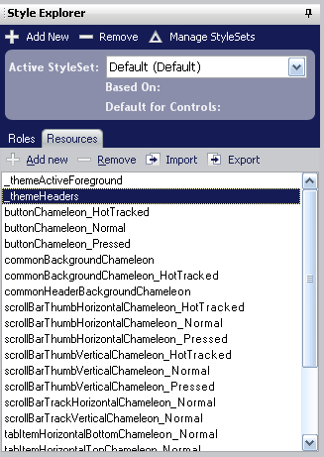

- Customize the look of library-wide headers by changing the background color. Tip: Achieve unique results by using a Gradient instead of a solid color for the background.

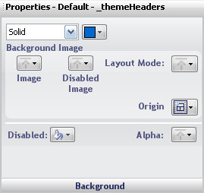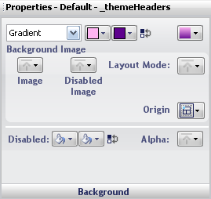
Select a header foreground color that complements your background colors.
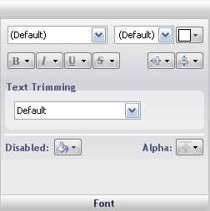

- Customize the appearance of active elements by modifying the _themeActiveForeground resource.
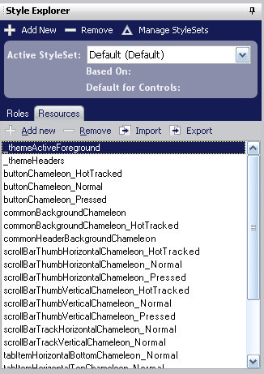

Chameleon Starter Palettes
 | _themeHeaders |  |  |  | _themeActiveForeground
 | BackgroundStyle | BackColor1 | BackColor2 | Foreground | Foreground
 | VerticalGradient | 255, 181, 242 | 74, 0, 113 | 255,255,255 | 118, 27, 156
 | VerticalGradient | 181, 193, 255 | 174, 158, 255 | 80, 79, 119 | 80, 79, 119
 | VerticalGradient | 90, 90, 90 | 195, 135, 255 | 255, 250, 240 | 123, 104, 142
 | VerticalGradient | 209, 0, 69 | 255, 67, 192 | 255, 255, 255 | 188, 11, 82
 | VerticalGradient | 255, 45, 255 | 255, 181, 193 | 255,255,255 | 200, 39, 198
 | VerticalGradient | 90, 90, 90 | 255, 181, 242 | 255, 250, 250 | 131, 113, 128
 | VerticalGradient | 254, 127, 0 | 186, 0, 31 | 255,255,255 | 197, 46, 16
 | VerticalGradient | 232, 154, 0 | 254, 84, 0 | 60, 60, 60 | 200, 108, 10
 | Solid | 186, 93, 0 | - | 255,255,255 | 186, 93, 0
 | Solid | 254, 0, 0 | - | 255,255,255 | 254, 0, 0
 | VerticalGradient | 255, 100, 22 | 255, 255, 90 | 118, 0, 0 | 118, 0, 0
 | VerticalGradient | 0, 73, 61 | 0, 164, 0 | 255,255,255 | 0, 164, 0
 | VerticalGradient | 216, 255, 22 | 174, 209, 0 | 19, 118, 0 | 19, 118, 0
 | VerticalGradient | 47, 141, 0 | 255, 255, 22 | 36, 73, 0 | 36, 73, 0
 | VerticalGradient | 0, 100, 0 | 173, 255, 47 | 255,255,255 | 48, 96, 0
 | VerticalGradient | 0, 193, 232 | 0, 136, 164 | 255,255,255 | 0, 122, 145
 | Solid | 0, 104, 209 | - | 255,255,255 | 0, 104, 209
 | VerticalGradient | 0, 82, 164 | 0, 254, 254 | 255, 255, 255 | 0, 124, 186
 | VerticalGradient | 30, 30, 30 | 181, 205, 255 | 236, 241, 252 | 87, 96, 114
 | VerticalGradient | 0, 118, 118 | 0, 186, 186 | 255, 255, 255 | 0, 135, 135
 | VerticalGradient | 181, 255, 193 | 181, 230, 255 | 90, 90, 90 | 72, 172, 128
 | VerticalGradient | 0, 193, 232 | 200, 255, 90 | 75, 75, 75 | 58, 120, 31

